|  |
| --- |
| 新东方在线英语学习 |
| 新概念 2 册 |
| Lesson71 |



扫一扫。更多有趣的英语资讯。

# Lesson 71 单词讲解

1. parliament n. 议会，国会

the Houses of Parliament 国会大厦

1. official n. 官员，行政人员

officer n. 军官，高级官员，高级职员

1. observatory n. 天文台

observe v. 观察，研究

1. check v. 检查，核对

May I check / see your passport?

n. 检查，支票

double check 再次检查

bank check 支票

1. microphone n. 扩音器，麦克风

micro- 微型的

MicroSoft 微软microwave oven 微波炉microscope 显微镜

1 parliament ['pɑ:ləmənt] n.议会，国会

2 erect [i'rekt] v.建起

3 accurate ['ækjurət] a.准确的

4 official [ə'fiʃəl] n.官员，行政人员

5 Greenwich ['grinidʒ] n.格林威治

6 observatory [əb'zə:vətəri] n.天文台

7 check [tʃek] v.检查

8 microphone['maikrəfəun] n.扩音器，麦克风

9 tower ['tauə] n.塔

# Lesson 71 课文&语法讲解

1. When you visit London, one of the first things you will see is Big Ben, the famous clock which

can be heard all over the world on the B.B.C.

复习分析句子

one of the first things you will see is Big Ben, L61

主 主 谓 谓从句

1. If the Houses of Parliament had not been burned down（烧毁） in 1834, the great clock would never have been erected.

虚拟条件句

假设过去 L64

1. Big Ben takes its name from Sir Benjamin … who was responsible for the making of the clock when the new Houses of Parliament were being built.

who 定语从句

when 时间状语从句

were being built 过去进行时的被动语态

Be responsible for 负责。。。

1. It is not only of immense size, but is extremely accurate as well.

并列句 L25

1. Officials from Greenwich Observatory have the clock checked twice a day.

have sth. done L58

1. On the B.B.C. you can hear the clock when it is actually striking because microphones are connected to the clock tower.
2. Once, however, it failed to give the correct time.

failed to 失败了去做某事 L55 L15

1. A painter who had been working on the tower hung a pot of paint on one of the hands and slowed it down!

a pot of paint 一桶油漆

hands 指针

who 定语从句 L28

had been doing 过去完成进行时 L62 and 并列句 L25

# Lesson 71 知识拓展

复习：

语言 —— 语法 —— 连词成句

1~3 单元 主要内容以句子为线索

复习方法：

* + 第 4 单元的复习重点内容的归纳总结
  + 把握 24 课的循环规律

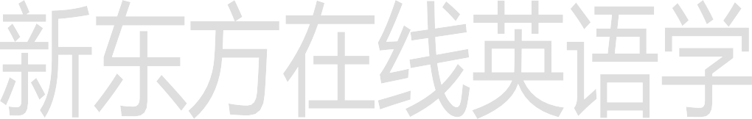例如：第 1-25-49-73 课，第 3-27-51-75 课… 复习的内容：

* + 背单词
  + 熟读课文
  + 复习笔记
  + 做针对性的真题
  + 少量多次，循环反复！